Jura and Islay seabed habitat PMF survey

Remote video sampling - 21 to 30 June, 2019

EMFF Engaging Fishermen in Marine Environmental Monitoring: Marine Scotland, Scottish Natural Heritage, Seascope Fisheries Research

Project Plan

Emergency contacts SNH Great Glen House reception: 01463 725000
Ben James (SNH): 01463 725235
Katie Gillham (SNH): 01463 725324
Elaine Tait (MS): 0131 244 0727 / 07393 753495

Scottish Natural Heritage
Contact: Caitlin Orr
Tel: 01463 725283
e-mail: Caitlin.Orr@nature.scot

Copies of both the project plan & risk assessment must be available in the field for all operations. Fieldwork must not commence if the project plan and risk assessment are not available.

Table of Figures Page
Figure 1 Overview of 2019 EMFF sampling areas around Jura and Islay 5
Figure 2 North Jura polygon (NJ) showing the distribution of survey stations. 8
Figure 3 Loch Tarbert and surrounding area in western Jura polygon (WJ) showing the distribution of survey stations. 9
Figure 4 Northern Islay polygon (NI) showing the distribution of survey stations. 10
Figure 5 Laggan Bay and Loch Indaal polygon (LB) showing the distribution of survey stations. 11
Figure 6 Southern Islay polygon (SI) - a magnified map of the shallow survey area around Port Ellen. 12
Figure 7 Southern Islay polygon (SI) showing the distribution of survey stations. 13
Figure 8 Sound of Jura polygon (SOJ) - Map 1 showing the northern stations in the polygon. 14
Figure 9 Sound of Jura polygon (SOJ) - Map 2 showing the southern stations in the polygon. 15
Figure 10 Sound of Jura polygon (SOJ) - Map 3 showing the deep stations SOJ20-SOJ27 for fan mussel predictive habitat and survey stations in Loch Caolisport. 16
Figure 11 Loch Craignish polygon (LC) showing the distribution of survey stations. 17
Figure 12 Loch Sween polygon (LS) showing the distribution of survey stations. Hatched area shows MPA. 18
Figure 13 Southern Sound of Islay and the Small Isles (SSI). Map 1 showing the distribution of survey stations east towards the Small Isles. 19
Figure 14 Southern Sound of Islay (SSI). Map 2 showing the distribution of survey stations south west of horse mussel and flame shell possible predictive habitat. 20
Figure 15 Mull of Kintyre and Gigha polygon (KG) showing the distribution of survey stations. Map 1 showing the northern stations in the polygon 21
Figure 16 Mull of Kintyre and Gigha polygon (KG) showing the distribution of survey stations. Map 2 showing the stations in the Sound of Gigha. 22
Figure 17 Mull of Kintyre and Gigha polygon (KG) showing the distribution of survey stations. Map 2 showing the southern stations in the polygon 23

Project objectives
- To deploy a drop-down video (DDV) system and complete new seabed habitat sampling as part of an EMFF (European Marine Fisheries Fund) project entitled “Engaging Fishermen in Marine Environmental Monitoring”.
- To undertake a programme of targeted DDV sampling to enhance our understanding of the distribution and extent of benthic PMFs around Jura and Islay, as well as improve our understanding of the broad distribution of seabed habitats.

Scope of works
- Complete 10 days of targeted drop-down video sampling from 21 to 30 June 2019, using the EMFF DDV system (to an est. max. depth of 200 m).
- The EMFF or SNH DDV equipment will be deployed from a chartered fishing vessel (Lady Nicola).

Methods
The focus of the sampling is to carry out targeted priority marine feature (PMF) surveys including flame shell beds, maerl beds and sea grass beds. DDV will be used to confirm habitat presence, extent and the current status of such features. The survey will build upon earlier studies to refine available habitat maps and to fill knowledge gaps.

Figure 1 (overleaf) shows the proposed sampling areas. For tide times see Appendix 2.

A small number of stations have are proposed in waters shallower than 10 m. Adjacent >10 m depth waters should be sampled where these shallower stations are inaccessible (for safety / logistical reasons etc.). These stations are marked in red on the more detailed area maps (Figs. 2-15) and in Table A1 (Appendix 1).

The DDV system will be deployed from the fishing vessel at pre-identified coordinates (see Table A1, Appendix 1). The camera will be lowered over the side of the vessel and positioned just above the seabed. A live feed of the video signal to the surface will enable the height above the seabed to be adjusted throughout each deployment, and lasers will enable the field of view to be judged.

The vessel will drift in the direction of any prevailing current (normally for 5-10 mins but up to 20 mins depending on the habitats encountered - although shorter runs may be appropriate in narrow channels / constrained shallow water areas). Vessel speed must remain at or below 1.2 knots to create usable video footage. Slow motoring against wind or tide might be considered to achieve this if drifting speeds are too high.

The Surface Control Unit (SCU) will display live SD video with time/date stamp, GPS location (when connected) and camera depth. LED lighting levels can be controlled from the SCU. HD video and still photos will be stored in the camera.

Video should be stored as highest available quality (MPEG4 for digital storage) and maximum bitrate (6000,000bits/s) unless storage capacity is limited. For snapshots bitmap (BMP) format is preferable to JPEG to maintain image quality for zooming in, and snapshot quality should be set at 100.

Sample location and other metadata will be recorded on paper forms throughout the survey as a check and backup to the video data, forms to be photographed and stored ashore at the end of each survey day. Station lat/long, time and depth data to be recorded on the forms from the vessel Olex navigation system as backup to the DDV overlay and hand-held GPS data. At the end of each survey day:

- video files will be downloaded from the camera, files re-named and checked, multiple back-ups created and the camera memory cleared;
- field data sheets will be transcribed into the spreadsheet log. Tidal corrections should be applied to recorded station depths but likely after the survey work is completed;
- hand-held GPS waypoints downloaded;
- the depth log for all stations should also be saved and stored; and
- all data backed up according to the agreed protocols.
Issues with metadata - lessons learned
Hand-written field notes are an important aid / cross reference, especially for time and positional information. Any issues with recording (e.g. if camera cuts out or time in not recorded etc.) should be noted in detail on the survey log sheet. Notes should include where the GPS and time information were taken from, what format and whether converted or adjusted at any point (ultimately converted to UTC in the Excel spreadsheet at the end of each day). The hand written in / out details from the log sheet and time for each station should be supplemented in the Excel spreadsheet with that from the hand-held GPS waypoints taken for the start / end points. Ideally this should be completed at the end of each day but this may take place at the end of the survey. In this way the start / end will actually be on the track that is subsequently adopted (from the hand-held GPS). Where there is any doubt about the hand-held waypoints / track due to signal failure etc. then the positional information on the GPS overlay should be consulted and the start / end positions at the correct time should be adopted. Pictures of the log sheets should be taken each day and stored with the metadata.
Purpose and protocol for the collection of still image ‘snapshots’
The primary role for the majority of still image ‘snapshots’ is to aid habitat / species identification when the video footage is analysed (potentially providing finer resolution information to aid biotope assignments etc.). These snapshots should be taken by the surveyor periodically throughout each video run in areas representative of the habitat and when conditions permit (frame landing, slow moving etc.). The frequency of still image shots should be decided by the surveyors at the time and will likely depend on the degree of habitat variability, the type of habitat and vessel speed.

Survey overview and priorities
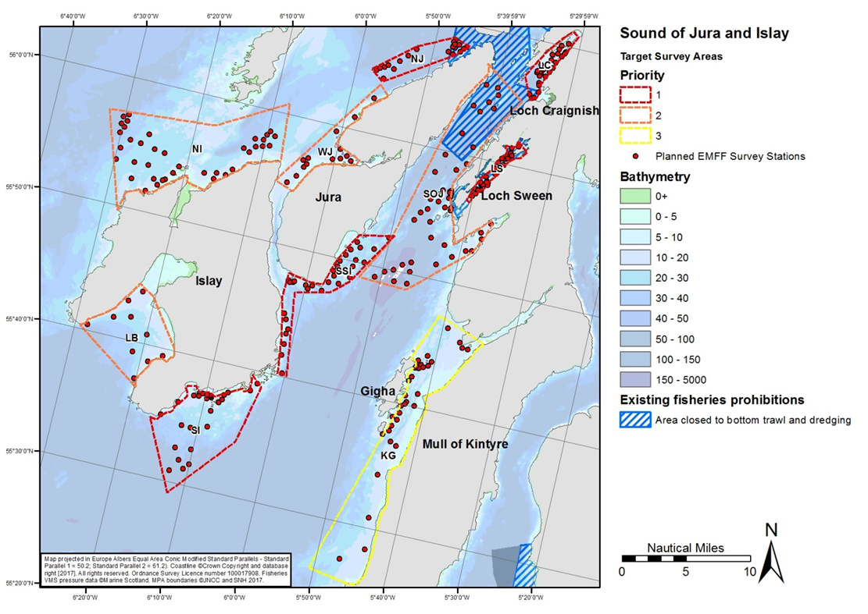
Figure 1 Overview of 2019 EMFF sampling areas around Jura and Islay

Priority 1 Priority Marine Feature check - validation of historic records
Re-evaluation of existing PMF records including for horse mussel beds, maerl beds, fan mussels, northern sea fan & sponge communities and burrowed mud. Assessment of MSS fan mussel habitat predictive modelling in shallow and deep water. Assessment of PMF predicted flame shell bed habitat.
- Loch Sween (LS) - Figure 12; page 22
- Northern Jura (NJ) - Figure 2; page 12
- South Islay (SI) - Figures 6 & 7; pages 16 & 17
- Loch Craignish (LC) - Figure 11; page 21
- South Sound of Islay and Small Isles (SSI) - Figures 13 & 14; pages 23 &24

Priority 2 Inventory and extent of habitats
Inventory sampling to improve our understanding of the broad distribution of seabed habitats - targeted, depth-stratified sampling (North Islay, Jura channel, Western coastline of Mull of Kintyre and Gigha)
- Northern Islay (NI) - Figure 4; page 14
- Sound of Jura channel (SOJ) - Figures 8, 9 &109; pages 18-20
- Laggan bay (LB) - Figure 5; page 15
- Western Jura Coastline (WJ) - Figure 3; page 13

Priority 3 Inventory and extent of habitats in the Gigha channel
Inventory sampling of survey area (KG) should be completed if all other options are exhausted or this is the only area accessible under prevailing weather conditions. This area is also been surveyed as part of the MarPAMM project so this is to avoid overlap.
- Mull of Kintyre and Gigha (KG) - Figures 15, 16 & 17; pages 25,26 & 27

The order of surveying the different polygons will depend on the weather. There is no expectation that all stations will be surveyed during the survey. Preference will be to collect samples from Priority 1 areas first, in combination with some samples from nearby Priority 2 or 3 areas if efficient in terms of timing and weather.

Local conditions
- Much of the inventory sampling work is focussed on habitats in nearshore areas, generally shallower than 50 m. Some proposed sampling points are in areas of shallow water and may not be accessible (Appendix 1 - yellow highlighted stations). Proposed survey of other habitats and PMFs is expected to extend the operating depths to a maximum of 250m, with survey stations planned in deep water to 200 m (Appendix 1 - red highlighted stations >100 m).
- The presence of creels may affect access to sampling stations.
- The presence of fish farms may prevent access some to sampling stations. In this situation an alternative suitable location nearby proposed stations can be surveyed.
- Survey logistics for this area could be challenging. The Sound of Jura can be extremely difficult to work with very strong currents and sampling will need to be completed around slack water windows. If current speed or the sea state is not appropriate for DDV work, nearby more sheltered polygons in loch systems would be a good alternative to survey.
- Multiple ports will need to be used over the course of the trip to avoid long transit times and maximise time available for sampling.
- Inventory/gap filling stations can be flexible, if the vessel crew know of locations (or former locations) of habitats of interest, stations can be selected in these areas.
- In the Sound of Jura, south of Loch Crinan, the rise of tide occurs mainly during the 3 hours 30 minutes following Low Water, and the fall during the 3 hours 30 minutes following High Water. At other times the changes in level are usually small and irregular. At Port Ellen weather conditions have a marked effect on sea level, southerly and easterly gales raising the level up to 1 metre; at Neaps the tide is sometimes diurnal, while the range is negligible. At Machrihanish the difference between Springs and Neaps is not more than 0.2 metres.
- Loch Criagnish, Loch Sween and Loch Caolisport (in Sound of Jura polygon) sampling polygons have a shallow sill at the entrance to the sea lochs (seabed ~8 m above chart datum).
- Some sampling stations in the Kintyre and Gigha polygon (KG) are in the ferry route - KG19, KG20 and KG21. These stations should be surveyed with caution to scheduled ferry times.

Station locations
The maps on the following pages are presented in approximate order of priority for video sample collection but this will vary according to weather/tidal conditions at the time.

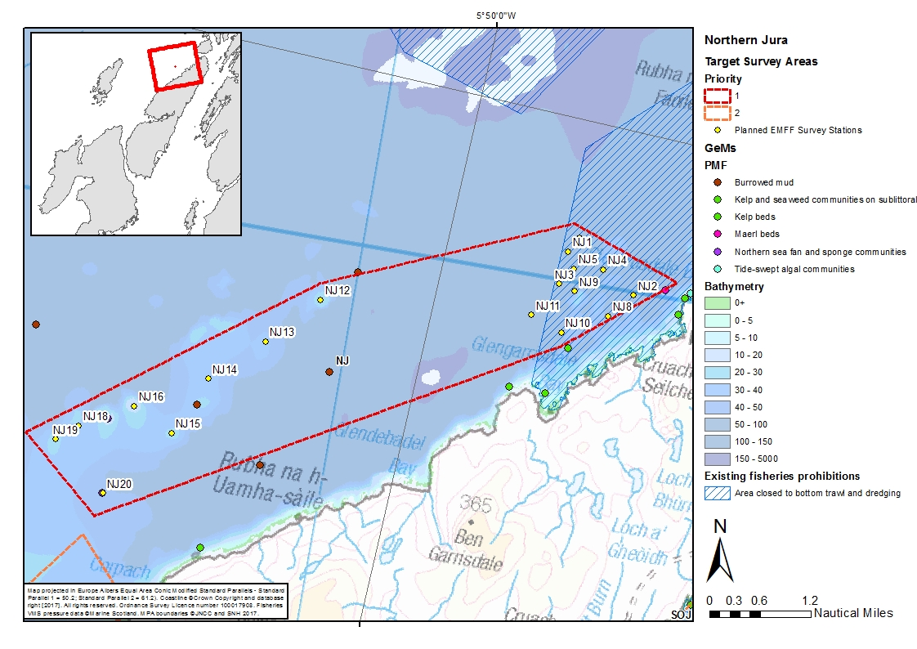
Figure 2 North Jura polygon (NJ) showing the distribution of survey stations.
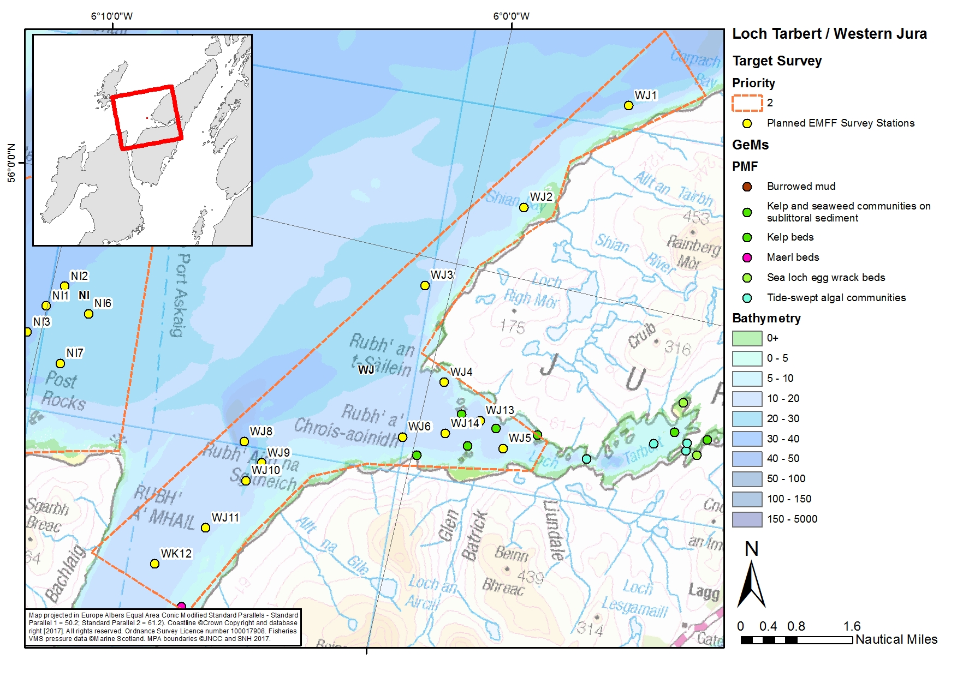
Figure 3 Loch Tarbert and surrounding area in western Jura polygon (WJ) showing the distribution of survey stations.
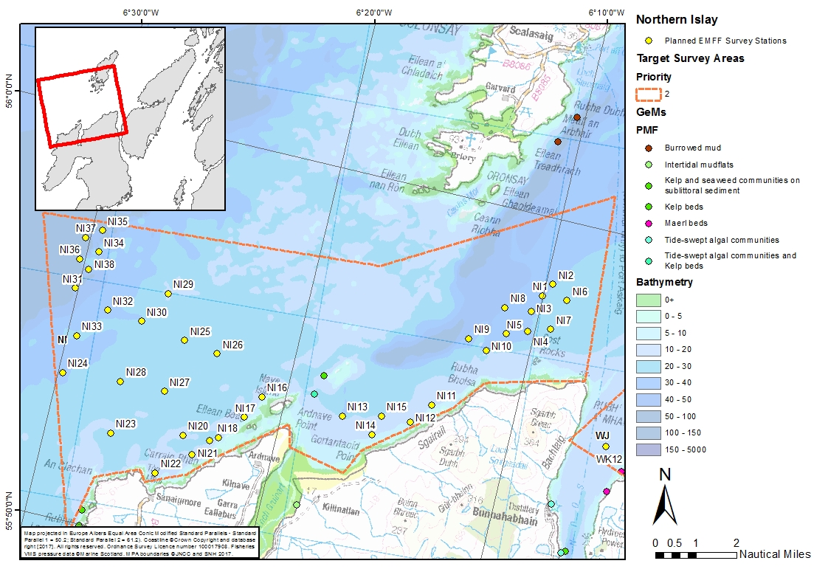
Figure 4 Northern Islay polygon (NI) showing the distribution of survey stations.

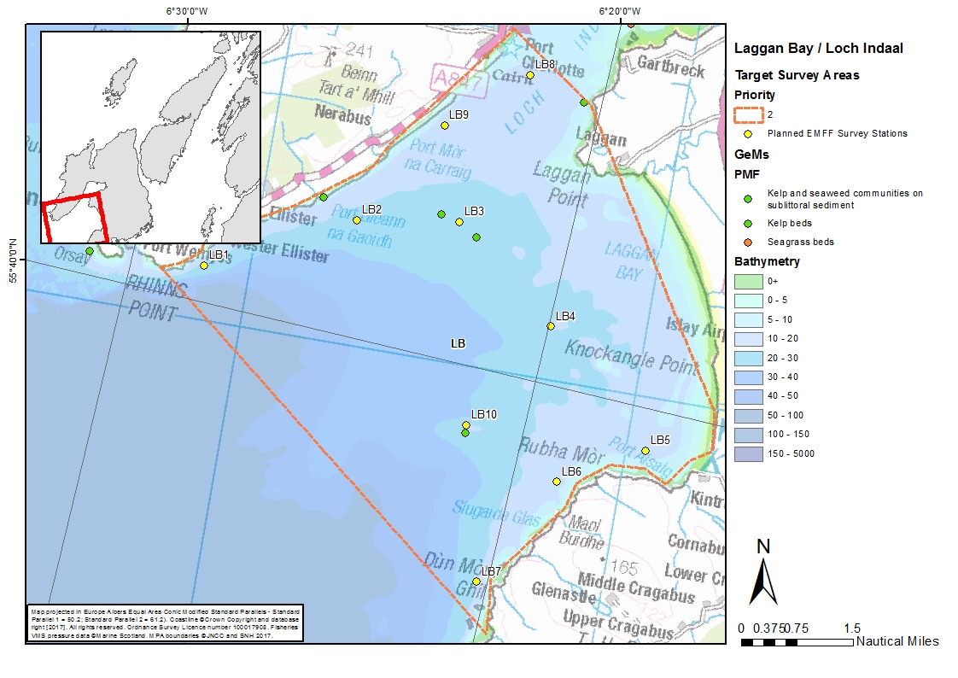
Figure 5 Laggan Bay and Loch Indaal polygon (LB) showing the distribution of survey stations.
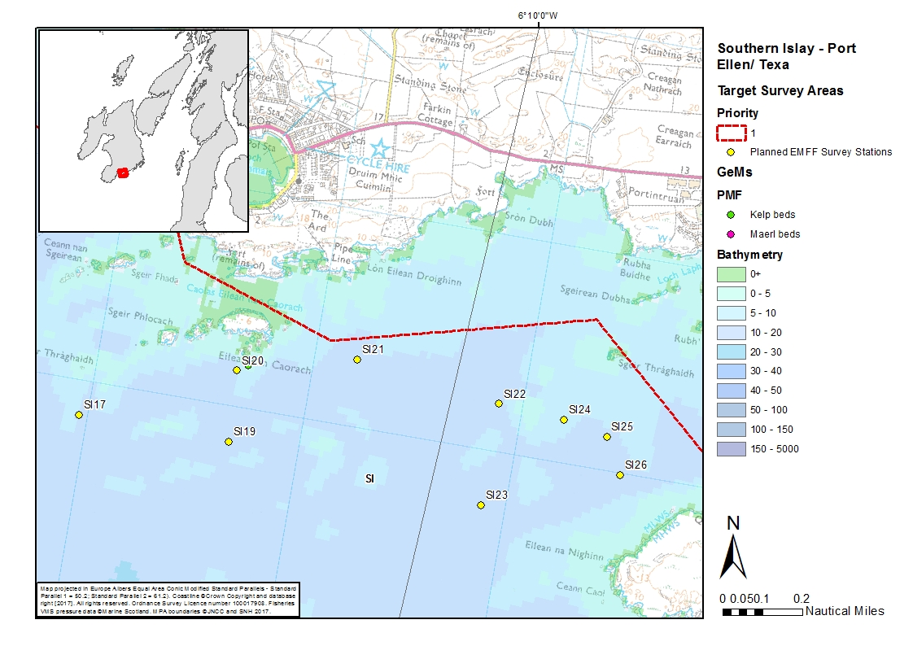
Figure 6 Southern Islay polygon (SI) - a magnified map of the shallow survey area around Port Ellen.
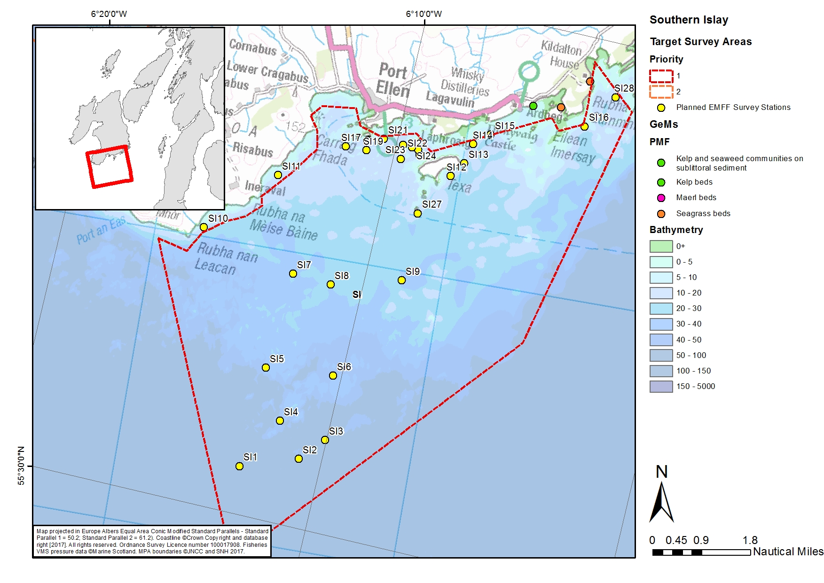
Figure 7 Southern Islay polygon (SI) showing the distribution of survey stations.
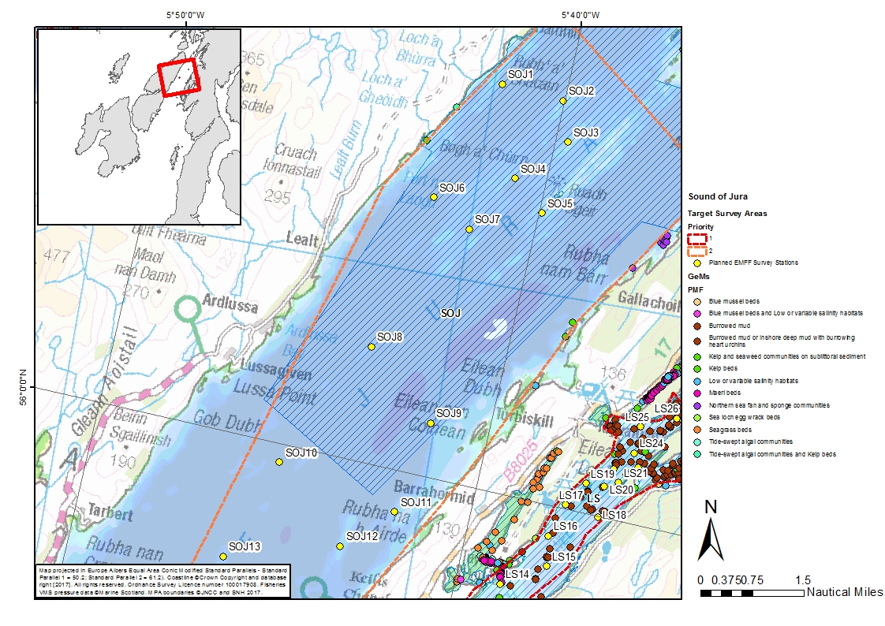
Figure 8 Sound of Jura polygon (SOJ) - Map 1 showing the northern stations in the polygon.
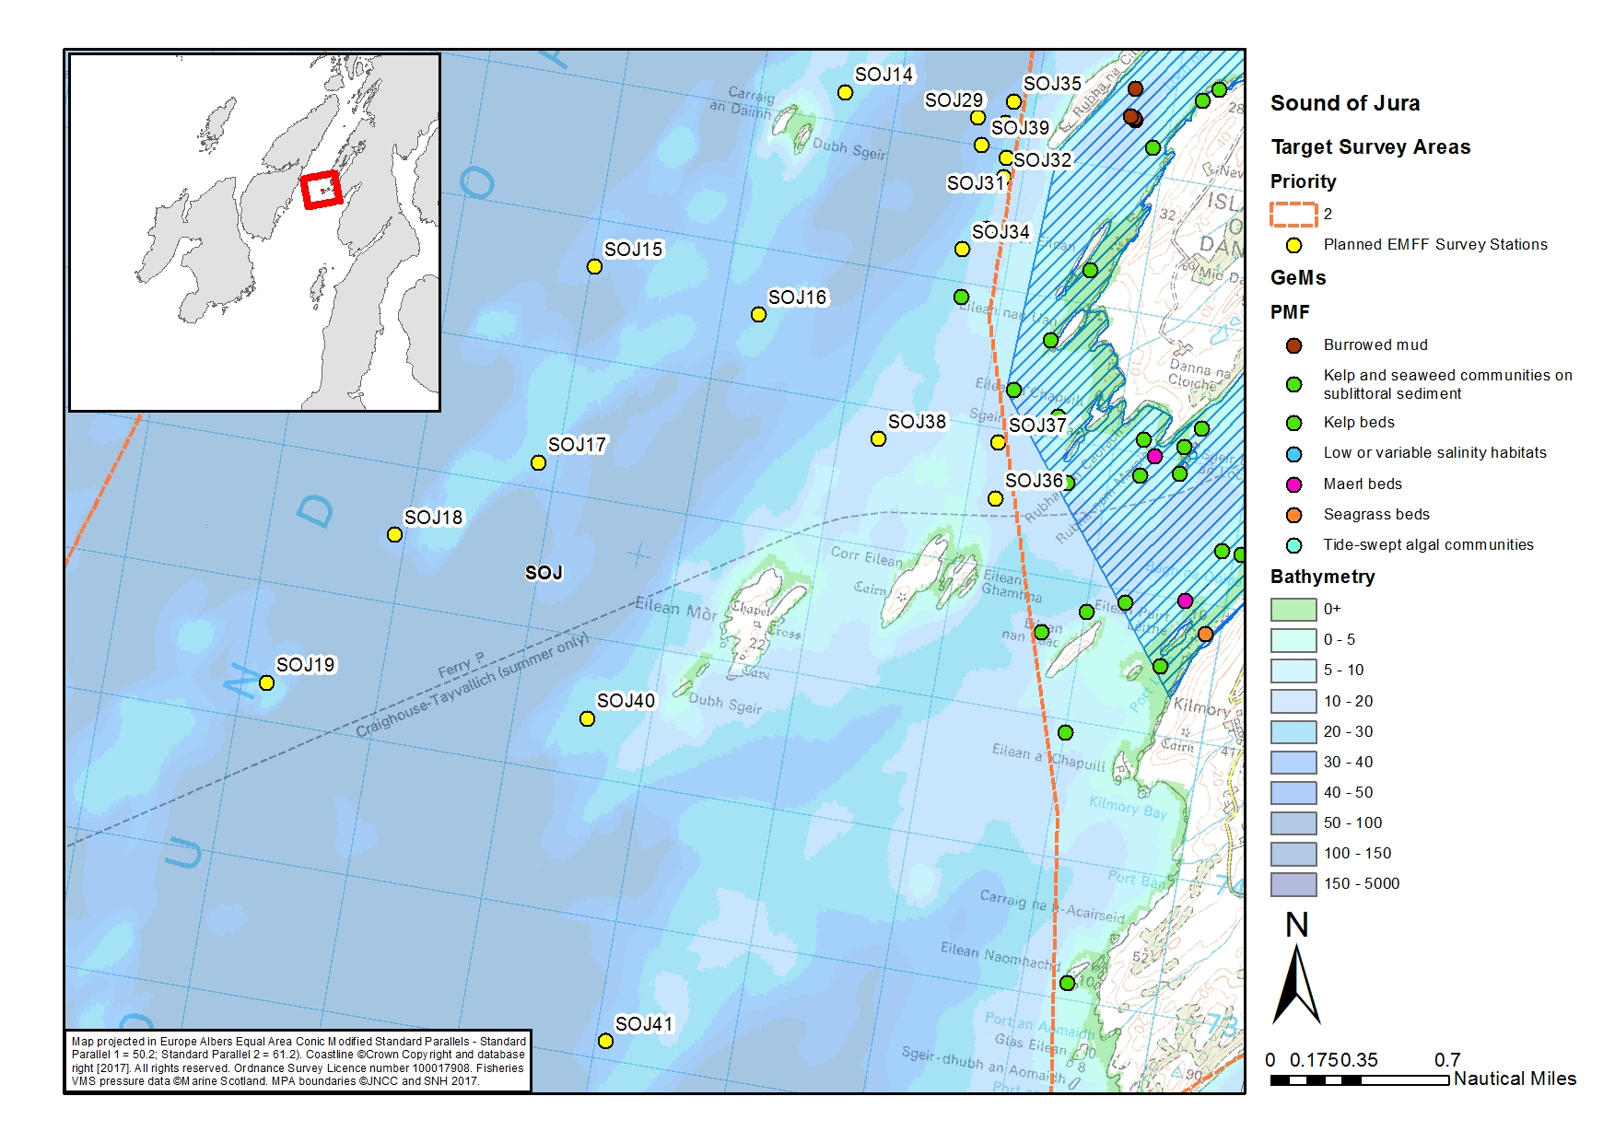
Figure 9 Sound of Jura polygon (SOJ) - Map 2 showing the southern stations in the polygon.
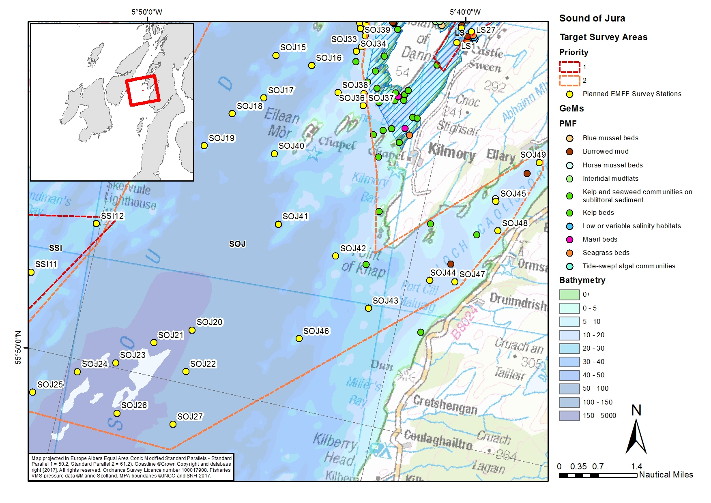
Figure 10 Sound of Jura polygon (SOJ) - Map 3 showing the deep stations SOJ20-SOJ27 for fan mussel predictive habitat and survey stations in Loch Caolisport.

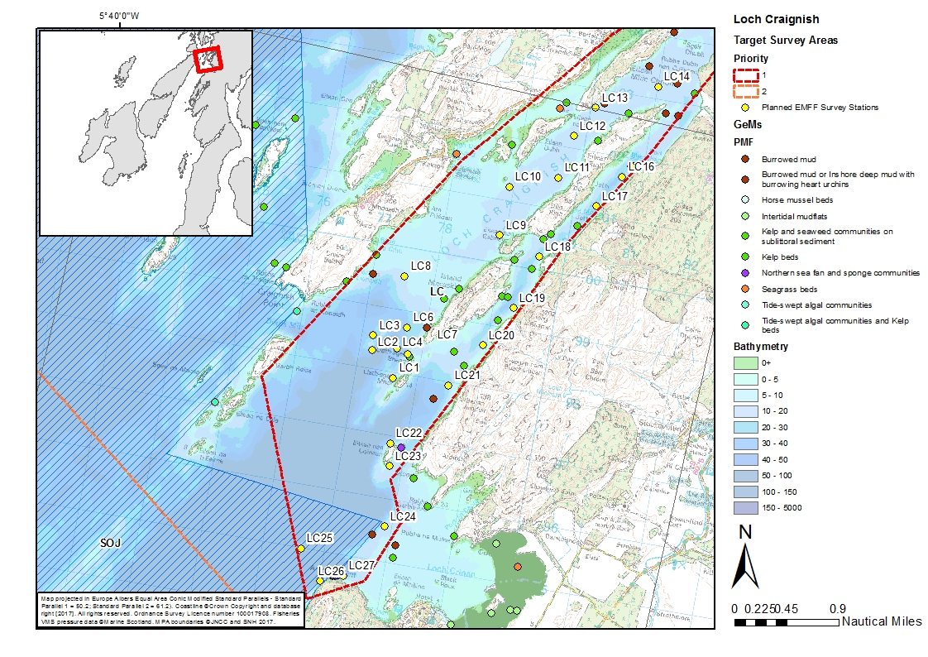
Figure 11 Loch Craignish polygon (LC) showing the distribution of survey stations.
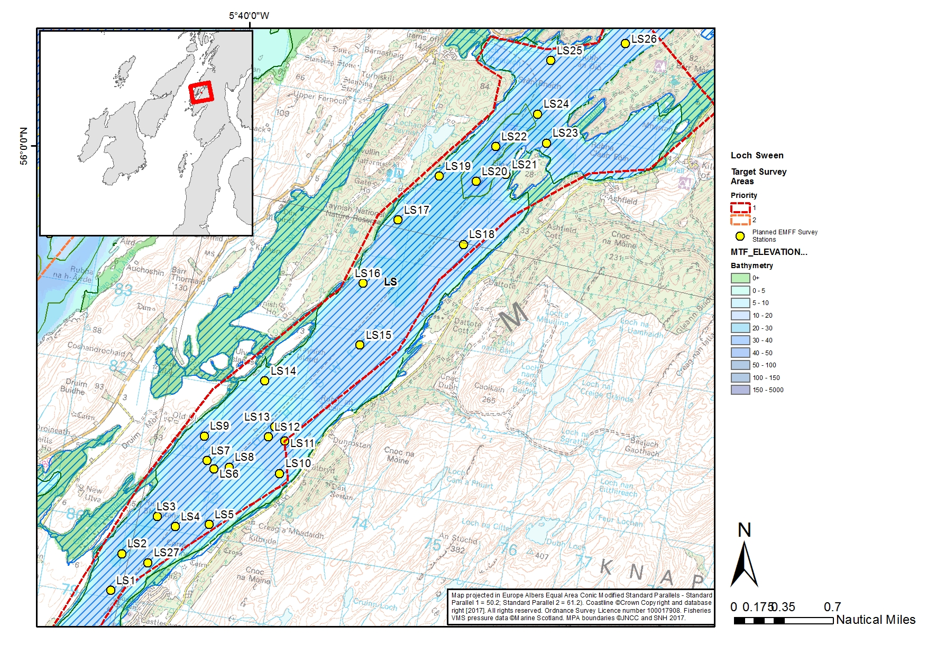
Figure 12 Loch Sween polygon (LS) showing the distribution of survey stations. Hatched area shows MPA.
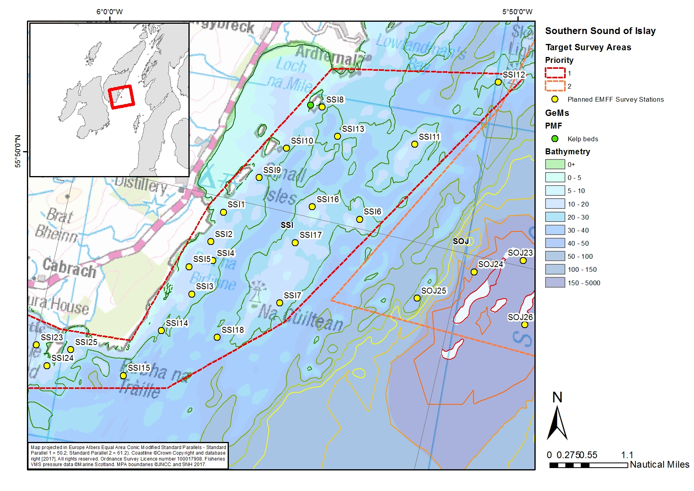
Figure 13 Southern Sound of Islay and the Small Isles (SSI). Map 1 showing the distribution of survey stations east towards the Small Isles.
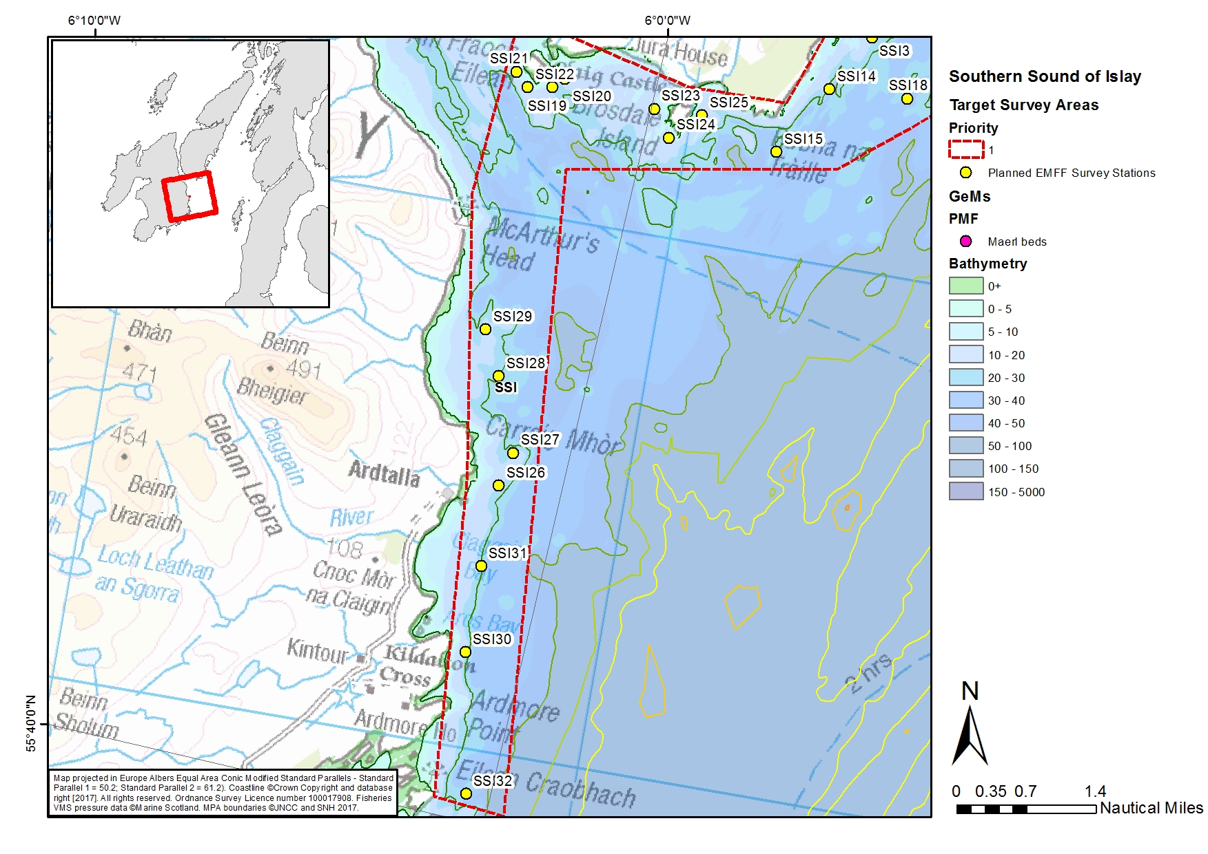
Figure 14 Southern Sound of Islay (SSI). Map 2 showing the distribution of survey stations south west of horse mussel and flame shell possible predictive habitat.
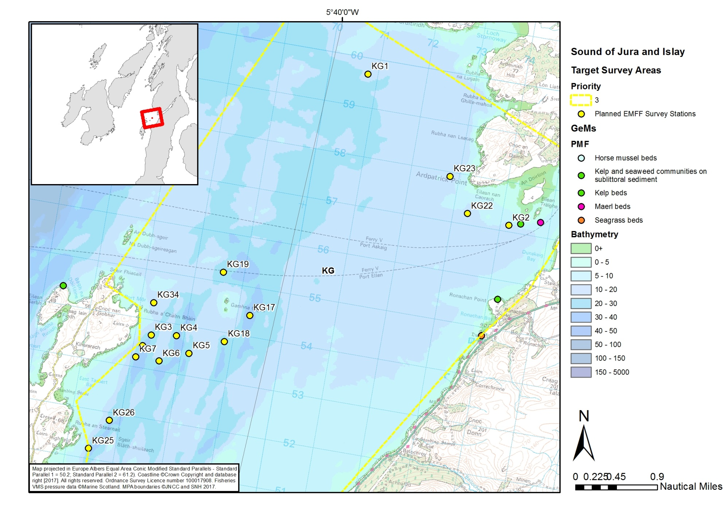
Figure 15 Mull of Kintyre and Gigha polygon (KG) showing the distribution of survey stations. Map 1 showing the northern stations in the polygon
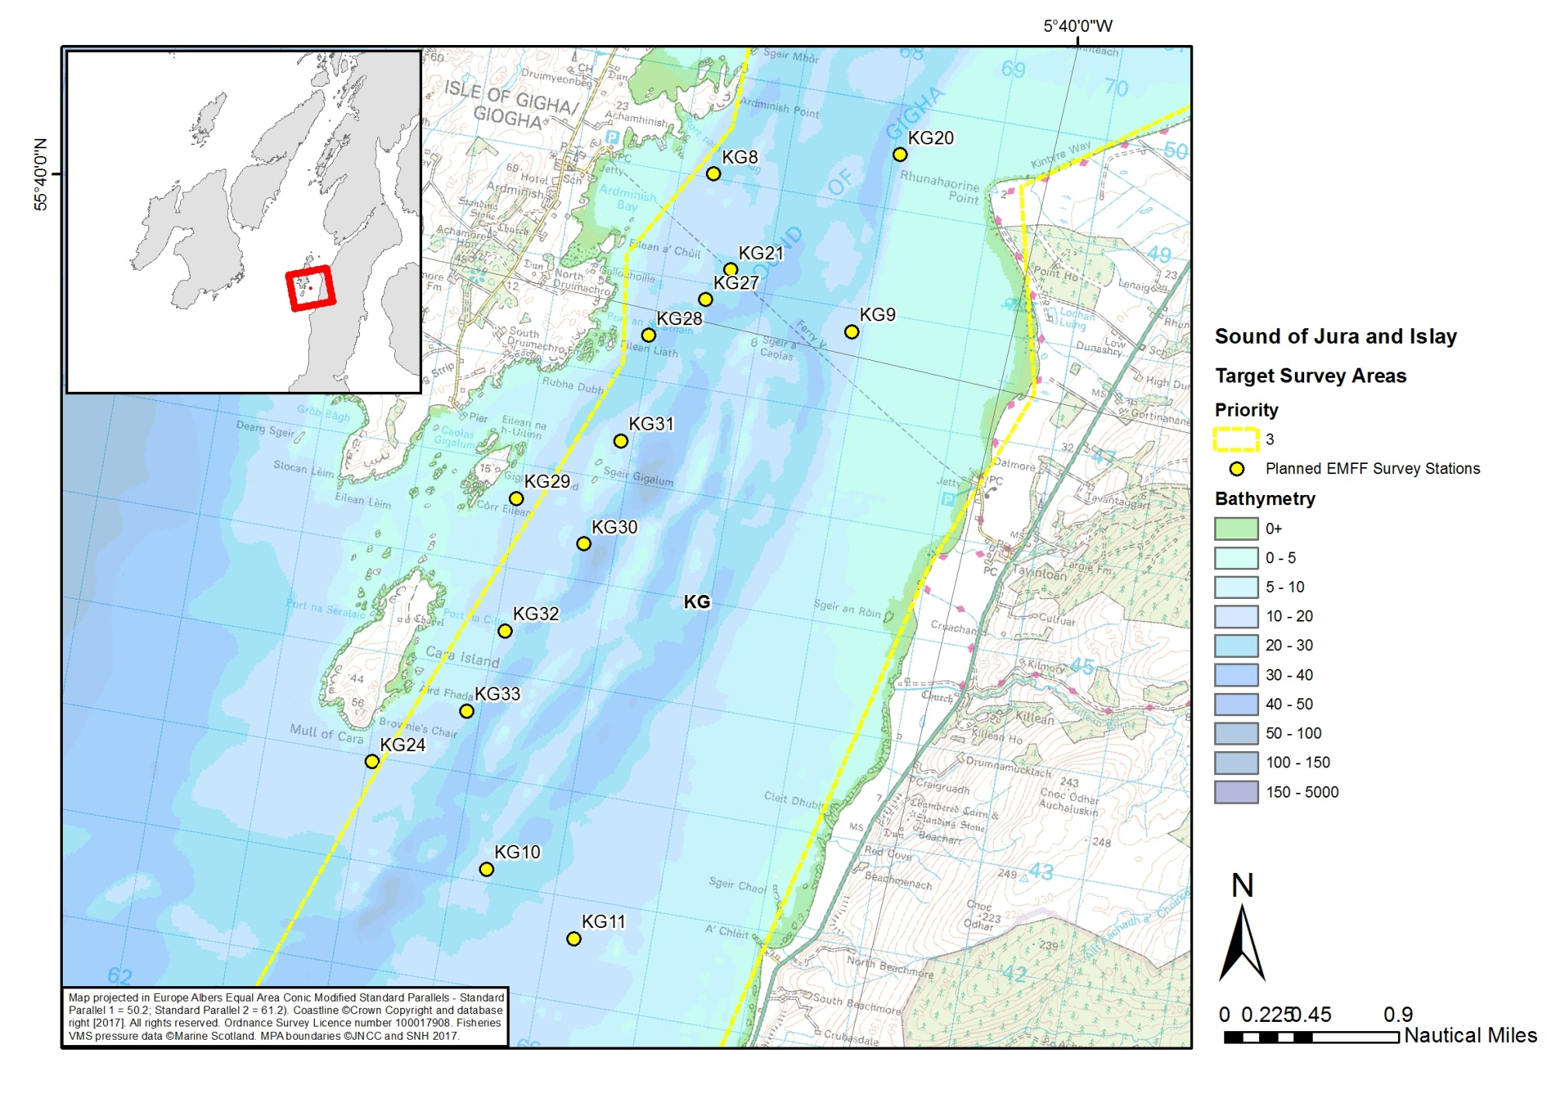
Figure 16 Mull of Kintyre and Gigha polygon (KG) showing the distribution of survey stations. Map 2 showing the stations in the Sound of Gigha.
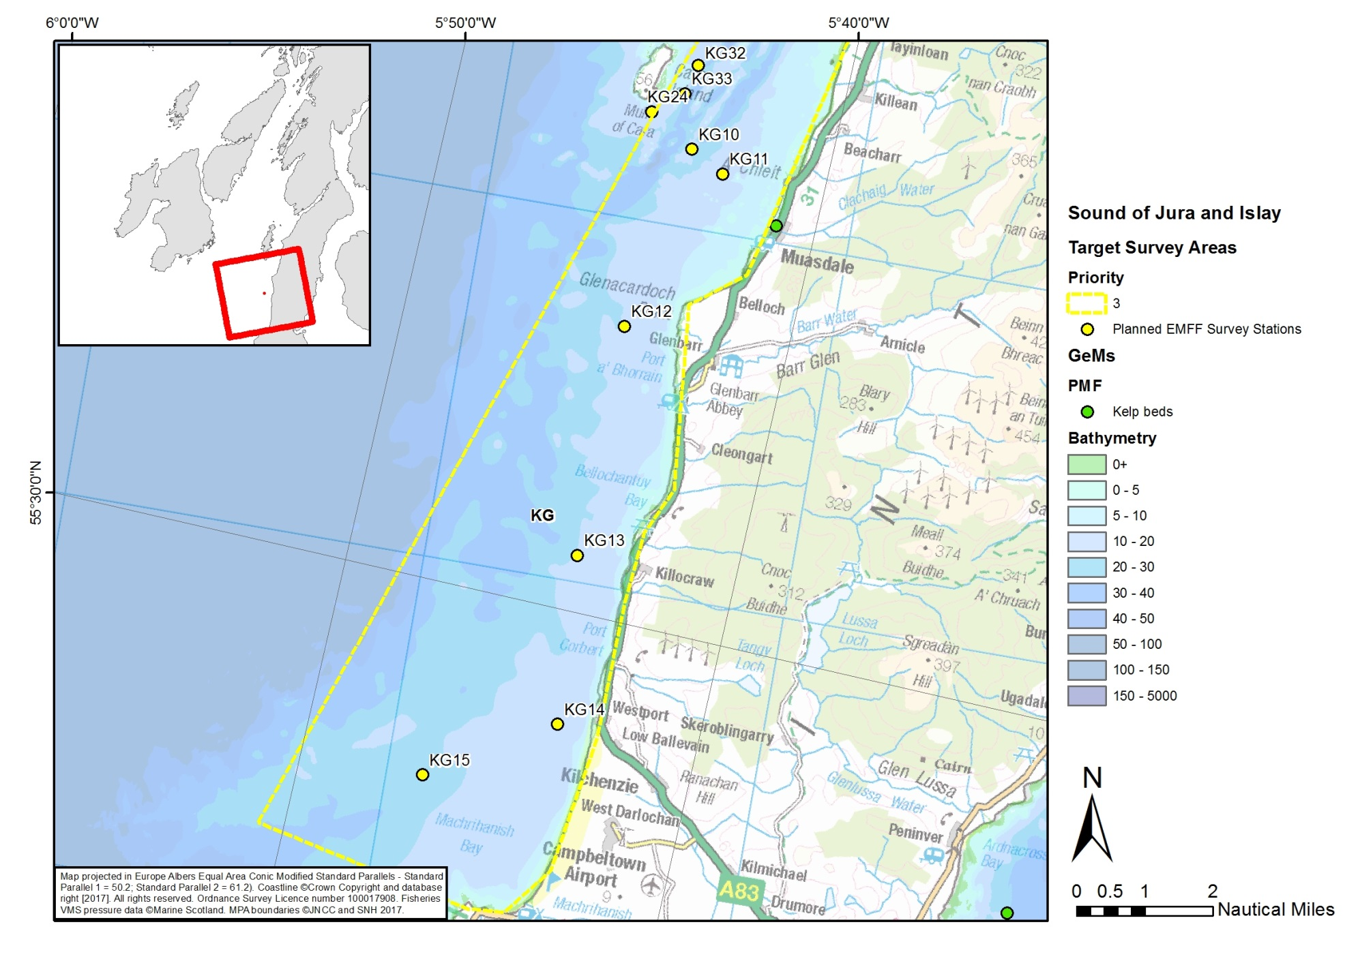
Figure 17 Mull of Kintyre and Gigha polygon (KG) showing the distribution of survey stations. Map 3 showing the southern stations in the polygon

Appendix 1 - Details of the drop-down video stations
Table A1 Details of drop-down video stations for the 2019 Jura and Islay survey
Stations <10m below chart datum highlighted in yellow and stations >100m are highlighted in red
Box | Station no. | Lat (deg dec min) | Long (deg dec min) | Depth (m) | Purpose/target PMF | Complete
Mull of Kintyre and Gigha (KG) | KG1 | 55° 46.556' | -5° 39.382' | 20 | Inventory
 | KG10 | 55° 36.959' | -5° 43.708' | 10-20 | Inventory
 | KG11 | 55° 36.710' | -5° 42.785' | 10 | Inventory
 | KG12 | 55° 34.212' | -5° 44.386' | 20 | Inventory
 | KG13 | 55° 30.784' | -5° 44.250' | 20 | Inventory
 | KG14 | 55° 28.309' | -5° 43.774' | 10-20 | Inventory
 | KG15 | 55° 27.145' | -5° 46.890' | 20 | Inventory
 | KG2 | 55° 45.282' | -5° 36.032' | 8-10 | Inventory
 | KG3 | 55° 43.239' | -5° 42.383' | 25 | Horse mussel mang
 | KG4 | 55° 43.296' | -5° 41.896' | 30 | Horse mussel mang
 | KG5 | 55° 43.137' | -5° 41.582' | 20 | Horse mussel mang
 | KG6 | 55° 42.981' | -5° 42.122' | 20 | Horse mussel mang
 | KG7 | 55° 42.969' | -5° 42.585' | 30 | Horse mussel mang
 | KG8 | 55° 40.708' | -5° 43.105' | 10-20 | Inventory
 | KG9 | 55° 40.073' | -5° 41.546' | 20 | Inventory
 | KG16 | 55° 43.106' | -5° 42.504' | 35 | Check HMB
 | KG17 | 55° 43.691' | -5° 40.584' | 30-35 | Check HMB
 | KG18 | 55° 43.349' | -5° 40.959' | 20-30 | Check HMB
 | KG19 | 55° 44.086' | -5° 41.281' | 20-30 | Check HMB – In ferry route
 | KG20 | 55° 41.018' | -5° 41.476' | 20-30 | Check HMB – Off headland
 | KG21 | 55° 40.246' | -5° 42.754' | 20-30 | Check HMB – In ferry route
 | KG22 | 55° 45.308' | -5° 36.874' | 10-15 | Check for HM
 | KG23 | 55° 45.663' | -5° 37.366' | 10-15 | Check for HM
 | KG24 | 55° 37.365' | -5° 44.953' | 15-20 | Check for HM
 | KG25 | 55° 41.875' | -5° 43.087' | 25 | Check for HM
 | KG26 | 55° 42.225' | -5° 42.809' | 25 | Check for HM
 | KG27 | 55° 40.067' | -5° 42.919' | 20-30 | Check for HM
 | KG28 | 55° 39.823' | -5° 43.354' | 20-30 | Check for HM
 | KG29 | 55° 38.852' | -5° 44.204' | 10 | Inventory
 | KG30 | 55° 38.702' | -5° 43.509' | 25-30 | Check for HM
 | KG31 | 55° 39.262' | -5° 43.385' | 10 | Inventory
 | KG32 | 55° 38.175' | -5° 44.035' | 10 | Inventory
 | KG33 | 55° 37.729' | -5° 44.211' | 15-30 | Check for HM
 | KG34 | 55° 43.591' | -5° 42.479' | 10-20 | Check for HM/FS
Laggan Bay (LB) | LB1 | 55° 40.433' | -6° 28.384' | 20-30 | Inventory
 | LB10 | 55° 39.184' | -6° 21.448' | 20-30 | Brittle star bed
 | LB2 | 55° 41.491' | -6° 25.113' | 20-30 | Inventory
 | LB3 | 55° 41.785' | -6° 22.732' | 20-30 | Inventory
 | LB4 | 55° 40.716' | -6° 20.046' | 10-20 | Inventory
 | LB5 | 55° 39.402' | -6° 17.166' | 10-20 | Inventory
 | LB6 | 55° 38.725' | -6° 19.059' | 10-20 | Inventory
 | LB7 | 55° 37.187' | -6° 20.356' | 10-20 | Inventory
 | LB8 | 55° 43.907' | -6° 21.918' | 10-20 | Predicted FS Habitat
 | LB9 | 55° 42.987' | -6° 23.614' | 10-20 | Predicted FS Habitat
Loch Craignish (LC) | LC1 | 56° 7.323' | -5° 34.766' | 10 | Sea fan
 | LC10 | 56° 9.137' | -5° 33.667' | 10 | Inventory
 | LC11 | 56° 9.311' | -5° 32.959' | 10 | Inventory
 | LC12 | 56° 9.686' | -5° 32.867' | 10-20 | Inventory
 | LC13 | 56° 9.964' | -5° 32.630' | 8-10 | Inventory - kelp
 | LC14 | 56° 10.257' | -5° 31.756' | 10-20 | Inventory
 | LC15 | 56° 9.546' | -5° 31.893' | 20 | horse mussel
 | LC16 | 56° 9.435' | -5° 31.992' | 20-30 | horse mussel
 | LC17 | 56° 9.142' | -5° 32.289' | 20 | Inventory
 | LC18 | 56° 8.612' | -5° 32.974' | 10-20 | Inventory - kelp
 | LC19 | 56° 8.135' | -5° 33.186' | 10-20 | Inventory
 | LC2 | 56° 7.515' | -5° 35.186' | 20-30 | Sea fan
 | LC20 | 56° 7.765' | -5° 33.523' | 10-20 | Inventory
 | LC21 | 56° 7.362' | -5° 33.905' | 20-30 | Inventory - kelp
 | LC22 | 56° 6.770' | -5° 34.586' | 10-20 | Sea fan
 | LC23 | 56° 6.578' | -5° 34.520' | 10 | Sea fan
 | LC24 | 56° 6.063' | -5° 34.391' | 10-20 | Inventory
 | LC25 | 56° 5.720' | -5° 35.574' | 30-40 | Inventory
 | LC26 | 56° 5.485' | -5° 35.167' | 40 | Sea fan
 | LC27 | 56° 5.572' | -5° 34.842' | 20-30 | Sea fan
 | LC3 | 56° 7.641' | -5° 35.213' | 20-30 | Sea fan
 | LC4 | 56° 7.576' | -5° 34.812' | 20-30 | Sea fan
 | LC5 | 56° 7.546' | -5° 34.623' | 8-10 | Sea fan
 | LC6 | 56° 7.768' | -5° 34.732' | 30 | Sea fan
 | LC7 | 56° 7.875' | -5° 34.395' | 10-20 | Inventory
 | LC8 | 56° 8.194' | -5° 34.941' | 10 | Inventory
 | LC9 | 56° 8.716' | -5° 33.650' | 10 | Inventory
Loch Sween (LS) | LS1 | 55° 57.008' | -5° 40.225' | 10 | Burrowed mud
 | LS10 | 55° 58.079' | -5° 38.472' | 10 | Inventory
 | LS11 | 55° 58.310' | -5° 38.498' | 10 | Inventory
 | LS12 | 55° 58.314' | -5° 38.713' | 10 | Burrowed mud
 | LS13 | 55° 58.393' | -5° 38.661' | 10 | Native Oyster
 | LS14 | 55° 58.693' | -5° 38.917' | 10 | Maerl
 | LS15 | 55° 59.091' | -5° 37.840' | 10 | Burrowed Mud
 | LS16 | 55° 59.519' | -5° 37.979' | 20 | Burrowed Mud
 | LS17 | 56° 0.012' | -5° 37.722' | 10-20 | Burrowed Mud
 | LS18 | 55° 59.944' | -5° 36.845' | 10-20 | Burrowed Mud
 | LS19 | 56° 0.378' | -5° 37.339' | 10-20 | Inventory
 | LS2 | 55° 57.279' | -5° 40.192' | 10-20 | Native Oyster
 | LS20 | 56° 0.398' | -5° 36.861' | 30 | Burrowed Mud
 | LS21 | 56° 0.493' | -5° 36.518' | 10-20 | Burrowed Mud
 | LS22 | 56° 0.668' | -5° 36.721' | 30 | Burrowed Mud
 | LS23 | 56° 0.772' | -5° 36.100' | 10-20 | Burrowed Mud
 | LS24 | 56° 0.959' | -5° 36.291' | 30 | Burrowed Mud
 | LS25 | 56° 1.348' | -5° 36.283' | 10 | Burrowed Mud
 | LS26 | 56° 1.583' | -5° 35.406' | 10 | Burrowed Mud
 | LS27 | 55° 57.258' | -5° 39.847' | 10-20 | Mud / Seagrass
 | LS3 | 55° 57.590' | -5° 39.862' | 10-20 | Burrowed Mud
 | LS4 | 55° 57.548' | -5° 39.613' | 10 | Inventory
 | LS5 | 55° 57.617' | -5° 39.199' | 10 | Inventory
 | LS6 | 55° 58.007' | -5° 39.298' | 10 | Native Oyster
 | LS7 | 55° 58.053' | -5° 39.402' | 10 | Inventory
 | LS8 | 55° 58.043' | -5° 39.109' | 10 | Inventory
 | LS9 | 55° 58.218' | -5° 39.509' | 10 | Inventory
Northern Islay (NI) | NI1 | 55° 58.033' | -6° 10.137' | 30 | Invent - Horse M
 | NI10 | 55° 56.422' | -6° 11.983' | 25 | Invent - Horse M
 | NI11 | 55° 54.800' | -6° 13.772' | 10 | Inventory
 | NI12 | 55° 54.277' | -6° 14.513' | 10 | Inventory
 | NI13 | 55° 54.032' | -6° 17.482' | 20-30 | Predicted FS Habitat
 | NI14 | 55° 53.763' | -6° 16.021' | 10-20 | Predicted FS Habitat
 | NI15 | 55° 54.255' | -6° 15.799' | 20-30 | Predicted FS Habitat
 | NI16 | 55° 54.037' | -6° 21.129' | 10 | Inventory
 | NI17 | 55° 53.453' | -6° 21.683' | 10 | Inventory
 | NI18 | 55° 52.824' | -6° 22.573' | 10-20 | Inventory
 | NI19 | 55° 52.700' | -6° 22.907' | 20 | Inventory
 | NI2 | 55° 58.370' | -6° 9.790' | 30 | Invent - Horse M
 | NI20 | 55° 52.674' | -6° 24.118' | 20 | Inventory
 | NI21 | 55° 52.262' | -6° 23.513' | 10-20 | Inventory
 | NI22 | 55° 51.613' | -6° 24.903' | 10-20 | Inventory
 | NI23 | 55° 52.307' | -6° 27.216' | 20 | Inventory
 | NI24 | 55° 53.473' | -6° 29.888' | 30 | Inventory
 | NI25 | 55° 54.943' | -6° 24.998' | 20-30 | Inventory
 | NI26 | 55° 54.812' | -6° 23.477' | 20-30 | Inventory
 | NI27 | 55° 53.614' | -6° 25.340' | 20-30 | Inventory
 | NI28 | 55° 53.599' | -6° 27.331' | 20-30 | Inventory
 | NI29 | 55° 55.965' | -6° 26.195' | 20 | Invent - rock
 | NI3 | 55° 57.605' | -6° 10.462' | 30 | Invent - Horse M
 | NI30 | 55° 55.147' | -6° 27.053' | 20-30 | Invent - rock
 | NI31 | 55° 55.558' | -6° 30.226' | 50 | Invent - rock
 | NI32 | 55° 55.218' | -6° 28.606' | 30 | Invent - rock
 | NI33 | 55° 54.438' | -6° 29.686' | 30 | Invent - rock
 | NI34 | 55° 56.567' | -6° 29.606' | 30 | Invent - rock
 | NI35 | 55° 57.089' | -6° 29.659' | 50 | Invent - rock
 | NI36 | 55° 56.277' | -6° 30.331' | 50 | Invent - rock
 | NI37 | 55° 56.831' | -6° 30.300' | 50 | Invent - rock
 | NI38 | 55° 56.082' | -6° 29.845' | 40 | Invent - rock
 | NI4 | 55° 57.099' | -6° 10.404' | 30 | Invent - Horse M
 | NI5 | 55° 56.925' | -6° 11.285' | 35 | Invent - Horse M
 | NI6 | 55° 58.062' | -6° 9.029' | 25 | Invent - Horse M
 | NI7 | 55° 57.278' | -6° 9.441' | 25 | Invent - Horse M
 | NI8 | 55° 57.547' | -6° 11.612' | 40 | Invent - Horse M
 | NI9 | 55° 56.601' | -6° 12.853' | 35 | Invent - Horse M
Northern Jura (NJ) | NJ1 | 56° 8.403' | -5° 47.570' | 110 | Fan Mussel Predicted
 | NJ10 | 56° 7.459' | -5° 47.321' | 65 | predicted fan mussel
 | NJ11 | 56° 7.580' | -5° 48.018' | 115 | predicted fan mussel
 | NJ12 | 56° 7.195' | -5° 52.452' | 30 | Sea Fan and Sponge
 | NJ13 | 56° 6.573' | -5° 53.398' | 40 | Sea Fan and Sponge
 | NJ14 | 56° 5.992' | -5° 54.396' | 40 | Sea Fan and Sponge
 | NJ15 | 56° 5.275' | -5° 54.896' | 30 | Sea Fan and Sponge
 | NJ16 | 56° 5.483' | -5° 55.797' | 20-30 | Sea Fan and Sponge
 | NJ17 | 56° 5.270' | -5° 56.294' | 20 | Sea Fan and Sponge
 | NJ18 | 56° 5.111' | -5° 56.852' | 30-40 | Sea Fan and Sponge
 | NJ19 | 56° 4.893' | -5° 57.257' | 30 | Sea Fan and Sponge
 | NJ2 | 56° 8.074' | -5° 46.000' | 60 | Fan Mussel Predicted
 | NJ20 | 56° 4.403' | -5° 56.028' | 50 | Sea Fan and Sponge
 | NJ3 | 56° 8.010' | -5° 47.593' | 100 | Fan Mussel Predicted
 | NJ4 | 56° 8.288' | -5° 46.753' | 50 | Fan Mussel Predicted
 | NJ5 | 56° 8.221' | -5° 47.358' | 80 | Fan Mussel Predicted
Southern Islay (SI) | NJ6 | 56° 8.236' | -5° 45.653' | 60 | predicted fan mussel
 | NJ7 | 56° 8.586' | -5° 47.389' | 100 | predicted fan mussel
 | NJ8 | 56° 7.771' | -5° 46.425' | 50 | predicted fan mussel
 | NJ9 | 56° 7.963' | -5° 47.241' | 60 | predicted fan mussel
 | SI1 | 55° 30.832' | -6° 12.664' | 100 | predicted fan mussel
 | SI10 | 55° 34.941' | -6° 15.593' | 10-20 | Inventory
 | SI11 | 55° 36.182' | -6° 13.631' | 10 | Inventory
 | SI12 | 55° 36.891' | -6° 8.147' | 10-20 | Inventory
 | SI13 | 55° 37.176' | -6° 7.805' | 8-10 | Inventory
 | SI14 | 55° 37.555' | -6° 7.668' | 10 | Inventory
 | SI15 | 55° 37.793' | -6° 7.191' | 10-20 | Inventory
 | SI16 | 55° 38.338' | -6° 4.255' | 8-10 | Inventory
 | SI17 | 55° 36.976' | -6° 11.694' | 10 | Gap - maerl
 | SI19 | 55° 36.997' | -6° 11.019' | 10 | Gap - maerl
 | SI2 | 55° 31.210' | -6° 10.844' | 60 | predicted fan mussel
 | SI20 | 55° 37.174' | -6° 11.057' | 8-10 | Maerl & kelp bed
 | SI21 | 55° 37.269' | -6° 10.546' | 10 | Gap - maerl
 | SI22 | 55° 37.243' | -6° 9.886' | 8-10 | Gap - maerl
 | SI23 | 55° 36.987' | -6° 9.860' | 10 | Gap - maerl
 | SI24 | 55° 37.242' | -6° 9.586' | 8-10 | Maerl bed
 | SI25 | 55° 37.225' | -6° 9.384' | 10 | Gap - maerl
 | SI26 | 55° 37.140' | -6° 9.288' | 10 | Gap - maerl
 | SI27 | 55° 36.088' | -6° 8.916' | 10-20 | Inventory
 | SI3 | 55° 31.656' | -6° 10.153' | 70 | predicted fan mussel
 | SI4 | 55° 31.812' | -6° 11.726' | 40 | predicted fan mussel
 | SI5 | 55° 32.696' | -6° 12.578' | 35 | predicted fan mussel
 | SI6 | 55° 32.838' | -6° 10.383' | 40 | predicted fan mussel
 | SI7 | 55° 34.488' | -6° 12.412' | 30 | predicted fan mussel
 | SI8 | 55° 34.454' | -6° 11.136' | 30 | predicted fan mussel
 | SI9 | 55° 34.830' | -6° 8.917' | 30 | predicted fan mussel
 | SI28 | 55° 38.985' | -6° 3.493' | 15 | Check for FS/HM
Sound of Jura (SOJ) | SOJ1 | 56° 5.714' | -5° 41.764' | 50 | Gap - Sea fan sponge
 | SOJ10 | 55° 59.690' | -5° 45.208' | 60 | Gap - Sea fan sponge
 | SOJ11 | 55° 59.367' | -5° 42.000' | 30 | Gap - Sea fan sponge
 | SOJ12 | 55° 58.705' | -5° 43.175' | 30 | Gap - Sea fan sponge
 | SOJ13 | 55° 58.188' | -5° 46.079' | 40 | Gap - Sea fan sponge
 | SOJ14 | 55° 56.948' | -5° 44.383' | 20-30 | Inventory
 | SOJ15 | 55° 56.064' | -5° 45.825' | 50 | Gap - Sea fan sponge
 | SOJ16 | 55° 56.025' | -5° 44.625' | 30 | Gap - Sea fan sponge
 | SOJ17 | 55° 55.268' | -5° 45.899' | 30 | Gap - Sea fan sponge
 | SOJ18 | 55° 54.867' | -5° 46.772' | 50 | Gap - Sea fan sponge
 | SOJ19 | 55° 54.190' | -5° 47.415' | 30 | Gap - Sea fan sponge
 | SOJ2 | 56° 5.679' | -5° 40.120' | 20 | Gap - Sea fan sponge
 | SOJ20 | 55° 50.925' | -5° 46.466' | 150 | deep predicted fm
 | SOJ21 | 55° 50.547' | -5° 47.577' | 175 | deep predicted fm
 | SOJ22 | 55° 50.173' | -5° 46.366' | 120 | deep predicted fm
 | SOJ23 | 55° 50.043' | -5° 48.622' | 200 | deep predicted fm
 | SOJ24 | 55° 49.732' | -5° 49.759' | 175 | deep predicted fm
 | SOJ25 | 55° 49.193' | -5° 51.010' | 50 | deep predicted fm
 | SOJ26 | 55° 49.169' | -5° 48.221' | 190 | deep predicted fm
 | SOJ27 | 55° 49.199' | -5° 46.386' | 100 | deep predicted fm
 | SOJ28 | 55° 56.973' | -5° 43.238' | 25-30 | Check FSB
 | SOJ29 | 55° 56.967' | -5° 43.430' | 45 | Check FSB
 | SOJ30 | 55° 56.973' | -5° 43.238' | 35 | Check FSB
 | SOJ31 | 55° 56.838' | -5° 43.175' | 20-25 | Check FSB
 | SOJ32 | 55° 56.763' | -5° 43.161' | 20-25 | Check FSB
 | SOJ33 | 55° 56.552' | -5° 43.196' | 10-20 | Check FSB
 | SOJ34 | 55° 56.452' | -5° 43.332' | 10-20 | Check FSB
 | SOJ35 | 55° 57.060' | -5° 43.214' | 31 | Check FSB
 | SOJ36 | 55° 55.532' | -5° 42.716' | 10 | Check FSB
 | SOJ37 | 55° 55.747' | -5° 42.781' | 10 | Check FSB
 | SOJ38 | 55° 55.655' | -5° 43.610' | 10-15 | Check FSB
 | SOJ39 | 55° 56.864' | -5° 43.367' | 40 | Check FSB
 | SOJ40 | 55° 54.335' | -5° 45.165' | 30 | Check FSB
 | SOJ41 | 55° 53.120' | -5° 44.530' | 30-35 | Check FSB
 | SOJ42 | 55° 52.794' | -5° 42.501' | 30 | Check FSB
 | SOJ43 | 55° 52.012' | -5° 41.098' | 20-25 | Check FSB
 | SOJ44 | 55° 52.742' | -5° 39.371' | 10-15 | Check HMB
 | SOJ45 | 55° 54.391' | -5° 37.866' | 10-15 | Check HMB
 | SOJ46 | 55° 51.203' | -5° 43.055' | 30 | Check HMB
 | SOJ47 | 55° 52.817' | -5° 38.574' | 10-15 | Check for FS/HM
 | SOJ48 | 55° 53.882' | -5° 37.594' | 10 | Check for FS/HM
 | SOJ49 | 55° 55.239' | -5° 36.788' | 10 | Check for FS/HM
 | SOJ3 | 56° 5.115' | -5° 39.756' | 20 | Gap - Sea fan sponge
 | SOJ4 | 56° 4.436' | -5° 40.883' | 50 | Gap - Sea fan sponge
 | SOJ5 | 56° 4.034' | -5° 40.013' | 30 | Gap - Sea fan sponge
 | SOJ6 | 56° 3.907' | -5° 42.835' | 80 | Gap - Sea fan sponge
 | SOJ7 | 56° 3.569' | -5° 41.757' | 50 | Gap - Sea fan sponge
 | SOJ8 | 56° 1.610' | -5° 43.542' | 40 | Gap - Sea fan sponge
 | SOJ9 | 56° 0.728' | -5° 41.608' | 60 | Gap - Sea fan sponge
South Sound of Islay & Small Isles | SSI1 | 55° 49.754' | -5° 56.226' | 10-20 | Predicted FS Habitat
 | SSI10 | 55° 50.827' | -5° 55.050' | 10-20 | Inventory
 | SSI11 | 55° 51.287' | -5° 51.941' | 10-20 | Inventory
 | SSI12 | 55° 52.396' | -5° 50.242' | 20-30 | Inventory
 | SSI13 | 55° 51.148' | -5° 53.871' | 20-30 | Inventory
 | SSI14 | 55° 47.939' | -5° 57.066' | 20-30 | Inventory
 | SSI15 | 55° 47.206' | -5° 57.741' | 20-30 | Inventory
 | SSI16 | 55° 50.108' | -5° 54.086' | 10-20 | Kelp beds
 | SSI17 | 55° 49.566' | -5° 54.301' | 10-20 | Kelp beds
 | SSI18 | 55° 48.023' | -5° 55.670' | 30-40 | Inventory
 | SSI19 | 55° 47.330' | -6° 1.910' | 10-20 | Maerl
 | SSI2 | 55° 49.311' | -5° 56.369' | 10-20 | Predicted FS Habitat
 | SSI20 | 55° 47.433' | -6° 1.727' | 10 | Maerl
 | SSI21 | 55° 47.396' | -6° 2.600' | 10 | Maerl
 | SSI22 | 55° 47.267' | -6° 2.348' | 10-20 | Maerl
 | SSI23 | 55° 47.346' | -6° 0.047' | 10-20 | Maerl
 | SSI24 | 55° 47.098' | -5° 59.668' | 10-20 | Maerl
 | SSI25 | 55° 47.391' | -5° 59.181' | 10-20 | Maerl
 | SSI3 | 55° 48.536' | -5° 56.531' | 10-20 | Predicted FS Habitat
 | SSI4 | 55° 49.061' | -5° 56.212' | 20 | Predicted FS Habitat
 | SSI5 | 55° 48.899' | -5° 56.757' | 10-20 | Predicted FS Habitat
 | SSI6 | 55° 50.089' | -5° 52.859' | 10-20 | Kelp beds
 | SSI7 | 55° 48.694' | -5° 54.332' | 10-20 | Kelp beds
 | SSI8 | 55° 51.500' | -5° 54.417' | 10-20 | Kelp beds
 | SSI9 | 55° 50.339' | -5° 55.554' | 20-30 | Inventory
 | SSI26 | 55° 43.313' | -6° 1.219' | 20 | Check for FS/HM
 | SSI27 | 55° 43.665' | -6° 1.102' | 20-25 | Check for FS/HM
 | SSI28 | 55° 44.384' | -6° 1.670' | 25 | Check for FS/HM
 | SSI29 | 55° 44.807' | -6° 2.087' | 20 | Check for FS/HM
 | SSI30 | 55° 41.614' | -6° 1.121' | 20 | Check for FS/HM
 | SSI31 | 55° 42.485' | -6° 1.196' | 25 | Check for FS/HM
 | SSI32 | 55° 40.228' | -6° 0.532' | 25-30 | Check for FS/HM
Loch Tarbert/ Western Jura (WJ) | WJ1 | 56° 2.725' | -5° 56.714' | 20-30 | Invent - maerl
 | WJ10 | 55° 56.253' | -6° 4.111' | 20 | Gap - maerl
 | WJ11 | 55° 55.468' | -6° 4.837' | 10 | Gap - maerl
 | WJ2 | 56° 0.966' | -5° 58.745' | 7-10 | Invent - maerl
 | WJ3 | 55° 59.556' | -6° 0.777' | 20 | Invent - maerl
 | WJ4 | 55° 58.274' | -5° 59.721' | 10 | Invent - maerl
 | WJ5 | 55° 57.538' | -5° 57.866' | 8-10 | Invent - maerl
 | WJ6 | 55° 57.373' | -6° 0.443' | 10-20 | Invent - maerl
 | WJ7 | 55° 56.998' | -6° 3.798' | 20-30 | Gap - maerl
 | WJ8 | 55° 56.792' | -6° 4.377' | 40 | Gap - maerl
 | WJ9 | 55° 56.553' | -6° 3.819' | 10-20 | Gap - maerl
 | WJ12 | 55° 54.796' | -6° 5.894' | 10-20 | Invent - maerl
 | WJ13 | 55° 57.853' | -5° 58.603' | 15-20 | Check for FS/HM
 | WJ14 | 55° 57.559' | -5° 59.392' | 15-20 | Check for FS/HM

Appendix 2 – Tidal information
0384 Loch Beag  56°09'N 5°36'W Scotland 21 June 2019 +0000  Predictions are based on OBAN | 0387 Carsaig Bay  56°02'N 5°38'W Scotland 21 June 2019 +0000  Predictions are based on OBAN | T039A 55 52 N 05 44 W  55°52'N 5°44'W North & NW Approaches 21 June 2019 +0000
21/06/2019  High 07:02 2.0 m  High 19:25 2.1 m  Low 01:34 0.6 m  Low 13:47 0.6 m  22/06/2019  High 07:37 1.9 m  High 20:02 2.0 m  Low 02:14 0.7 m  Low 14:27 0.7 m  23/06/2019  High 08:14 1.8 m  High 20:43 1.9 m  Low 02:56 0.8 m  Low 15:08 0.8 m  24/06/2019  High 08:55 1.7 m  High 21:29 1.9 m  Low 03:42 0.9 m  Low 15:52 0.9 m  25/06/2019 Last Quarter  High 09:45 1.7 m  High 22:26 1.8 m  Low 04:33 1.0 m  Low 16:41 1.0 m  26/06/2019  High 10:52 1.6 m  High 23:40 1.8 m  Low 05:31 1.0 m  Low 17:35 1.0 m  27/06/2019  High 12:14 1.7 m  Low 06:32 1.0 m  Low 18:34 1.0 m  28/06/2019  High 00:59 1.8 m  High 13:24 1.7 m  Low 07:29 0.9 m  Low 19:34 0.9 m  29/06/2019  High 02:00 1.9 m  High 14:17 1.9 m  Low 08:23 0.8 m  Low 20:34 0.8 m  30/06/2019  High 02:51 2.0 m  High 15:04 2.0 m  Low 09:11 0.6 m  Low 21:29 0.6 m  01/07/2019  High 03:39 2.1 m  High 15:49 2.1 m  Low 09:57 0.5 m  Low 22:21 0.5 m  Predicted heights are in metres above Chart Datum  British Crown Copyright © 2017 | 21/06/2019  High 07:07 1.6 m  High 19:30 1.7 m  Low 01:21 0.5 m  Low 13:35 0.5 m  22/06/2019  High 07:42 1.5 m  High 20:07 1.6 m  Low 02:02 0.6 m  Low 14:15 0.6 m  23/06/2019  High 08:19 1.4 m  High 20:48 1.5 m  Low 02:45 0.7 m  Low 14:57 0.6 m  24/06/2019  High 09:00 1.3 m  High 21:34 1.4 m  Low 03:32 0.7 m  Low 15:43 0.7 m  25/06/2019 Last Quarter  High 09:50 1.3 m  High 22:31 1.4 m  Low 04:25 0.8 m  Low 16:33 0.7 m  26/06/2019  High 10:57 1.2 m  High 23:45 1.4 m  Low 05:24 0.8 m  Low 17:28 0.8 m  27/06/2019  High 12:19 1.2 m  Low 06:26 0.7 m  Low 18:28 0.7 m  28/06/2019  High 01:04 1.4 m  High 13:29 1.3 m  Low 07:24 0.7 m  Low 19:29 0.7 m  29/06/2019  High 02:05 1.5 m  High 14:22 1.4 m  Low 08:16 0.6 m  Low 20:27 0.6 m  30/06/2019  High 02:56 1.6 m  High 15:09 1.5 m  Low 09:03 0.5 m  Low 21:20 0.5 m  01/07/2019  High 03:44 1.7 m  High 15:54 1.6 m  Low 09:47 0.4 m  Low 22:10 0.4 m  Predicted heights are in metres above Chart Datum  British Crown Copyright © 2017 | 21/06/2019  High 04:20 1.1 m  High 19:35 1.1 m  Low 00:54 0.5 m  Low 10:29 0.2 m  22/06/2019  High 04:53 1.1 m  High 20:02 1.0 m  Low 01:14 0.5 m  Low 11:00 0.2 m  23/06/2019  High 05:21 1.1 m  High 20:33 0.9 m  Low 01:32 0.6 m  Low 11:30 0.3 m  24/06/2019  High 05:50 1.1 m  High 21:14 0.9 m  Low 00:01 0.6 m  Low 12:01 0.3 m  25/06/2019 Last Quarter  High 06:24 1.0 m  High 22:05 0.8 m  Low 00:22 0.6 m  Low 12:39 0.4 m  26/06/2019  High 07:09 0.9 m  High 23:01 0.8 m  Low 00:57 0.7 m  Low 13:26 0.4 m  27/06/2019  High 08:10 0.8 m  High 23:52 0.9 m  Low 05:08 0.7 m  Low 14:30 0.5 m  28/06/2019  High 11:16 0.8 m  Low 06:19 0.6 m  Low 17:58 0.5 m  29/06/2019  High 00:30 0.9 m  High 12:12 0.8 m  Low 07:30 0.5 m  Low 18:47 0.5 m  30/06/2019  High 00:25 1.0 m  High 12:52 0.9 m  Low 08:44 0.4 m  Low 19:25 0.5 m  01/07/2019  High 00:43 1.0 m  High 16:01 0.9 m  Low 09:46 0.3 m  Low 21:50 0.5 m  Predictions should be read in conjunction with the graph  ML inferred  Predicted heights are in metres above Chart Datum  British Crown Copyright © 2017

0389 Sound Of Gigha  55°41'N 5°44'W Scotland 21 June 2019 +0000 | 0381 Port Ellen  55°38'N 6°11'W Scotland 21 June 2019 +0000 | 0378 Ardnave Point  55°52'N 6°20'W Scotland 21 June 2019 +0000  Predictions are based on OBAN
21/06/2019  High 05:08 0.9 m  High 18:10 0.9 m  Low 11:47 0.2 m  Low 23:54 0.5 m  22/06/2019  High 05:33 0.9 m  High 18:48 0.9 m  Low 12:05 0.2 m  23/06/2019  High 05:57 0.9 m  High 19:29 0.9 m  Low 00:00 0.6 m  Low 12:23 0.2 m  24/06/2019  High 06:18 0.9 m  High 20:13 0.8 m  Low 00:04 0.6 m  Low 12:44 0.3 m  25/06/2019 Last Quarter  High 06:34 0.8 m  High 21:06 0.8 m  Low 00:16 0.7 m  Low 13:10 0.3 m  26/06/2019  High 06:07 0.8 m  Low 00:36 0.7 m  Low 13:42 0.4 m  27/06/2019  High 04:45 0.8 m  High 23:39 0.7 m  Low 01:04 0.7 m  Low 14:26 0.4 m  28/06/2019  High 04:27 0.8 m  Low 01:53 0.7 m  Low 15:42 0.5 m  29/06/2019  High 00:56 0.8 m  High 12:03 0.7 m  Low 08:52 0.6 m  Low 19:45 0.5 m  30/06/2019  High 01:42 0.8 m  High 13:35 0.7 m  Low 09:08 0.5 m  Low 20:37 0.5 m  01/07/2019  High 02:19 0.9 m  High 14:38 0.8 m  Low 09:28 0.4 m  Low 21:17 0.4 m  Predicted heights are in metres above Chart Datum  British Crown Copyright © 2017 | 21/06/2019  High 04:18 0.7 m  High 20:03 0.6 m  Low 10:56 0.1 m  Low 23:19 0.4 m  22/06/2019  High 04:53 0.7 m  High 17:52 0.6 m  Low 11:28 0.1 m  Low 23:46 0.4 m  23/06/2019  High 05:26 0.7 m  High 18:25 0.6 m  Low 11:59 0.1 m  24/06/2019  High 05:58 0.6 m  High 19:00 0.5 m  Low 00:11 0.4 m  Low 12:31 0.1 m  25/06/2019 Last Quarter  High 06:30 0.6 m  Low 00:33 0.5 m  Low 13:04 0.1 m  Low 21:55 0.4 m  26/06/2019  High 03:36 0.5 m  Low 13:42 0.1 m  Low 22:41 0.4 m  27/06/2019  High 01:57 0.5 m  High 08:36 0.5 m  Low 14:31 0.2 m  Low 23:39 0.5 m  28/06/2019  High 02:17 0.5 m  High 10:06 0.5 m  Low 07:43 0.4 m  Low 16:01 0.2 m  29/06/2019  High 02:48 0.6 m  High 11:17 0.5 m  Low 08:22 0.3 m  Low 17:35 0.3 m  30/06/2019  High 03:26 0.6 m  High 12:17 0.5 m  Low 09:05 0.2 m  Low 18:38 0.3 m  01/07/2019  High 04:08 0.6 m  High 13:13 0.6 m  Low 09:49 0.1 m  Low 22:05 0.3 m  Predicted heights are in metres above Chart Datum  British Crown Copyright © 2017 | 21/06/2019  High 07:54 3.1 m  High 20:16 3.3 m  Low 02:06 1.1 m  Low 14:19 1.0 m  22/06/2019  High 08:27 3.0 m  High 20:51 3.2 m  Low 02:45 1.2 m  Low 14:57 1.1 m  23/06/2019  High 09:02 2.9 m  High 21:30 3.0 m  Low 03:25 1.3 m  Low 15:37 1.3 m  24/06/2019  High 09:41 2.8 m  High 22:12 2.9 m  Low 04:09 1.4 m  Low 16:20 1.4 m  25/06/2019 Last Quarter  High 10:27 2.7 m  High 23:06 2.8 m  Low 04:59 1.5 m  Low 17:07 1.5 m  26/06/2019  High 11:30 2.6 m  Low 05:55 1.5 m  Low 17:59 1.5 m  27/06/2019  High 00:16 2.8 m  High 12:50 2.7 m  Low 06:53 1.5 m  Low 18:55 1.5 m  28/06/2019  High 01:38 2.9 m  High 14:04 2.8 m  Low 07:50 1.4 m  Low 19:55 1.4 m  29/06/2019  High 02:42 3.0 m  High 15:00 2.9 m  Low 08:46 1.2 m  Low 20:58 1.2 m  30/06/2019  High 03:36 3.2 m  High 15:49 3.1 m  Low 09:37 1.0 m  Low 21:55 1.0 m  01/07/2019  High 04:26 3.3 m  High 16:37 3.3 m  Low 10:25 0.8 m  Low 22:50 0.9 m  Predicted heights are in metres above Chart Datum  British Crown Copyright © 2017

0377 Rubh' A' Mhail  55°56'N 6°07'W Scotland 21 June 2019 +0000  Predictions are based on OBAN | 0375 Glengarrisdale Bay  56°07'N 5°47'W Scotland 21 June 2019 +0000  Predictions are based on OBAN | 0380 Bruichladdich  55°46'N 6°22'W Scotland 21 June 2019 +0000
21/06/2019  High 07:48 3.2 m  High 20:11 3.4 m  Low 02:12 1.1 m  Low 14:25 1.0 m  22/06/2019  High 08:24 3.1 m  High 20:49 3.3 m  Low 02:51 1.2 m  Low 15:04 1.1 m  23/06/2019  High 09:00 3.0 m  High 21:31 3.1 m  Low 03:32 1.3 m  Low 15:44 1.3 m  24/06/2019  High 09:43 2.9 m  High 22:17 3.0 m  Low 04:17 1.4 m  Low 16:27 1.4 m  25/06/2019 Last Quarter  High 10:33 2.8 m  High 23:15 2.9 m  Low 05:07 1.5 m  Low 17:15 1.5 m  26/06/2019  High 11:41 2.7 m  Low 06:04 1.5 m  Low 18:07 1.5 m  27/06/2019  High 00:30 2.9 m  High 13:04 2.8 m  Low 07:03 1.5 m  Low 19:05 1.5 m  28/06/2019  High 01:48 3.0 m  High 14:12 2.9 m  Low 07:59 1.4 m  Low 20:05 1.4 m  29/06/2019  High 02:48 3.1 m  High 15:05 3.0 m  Low 08:55 1.2 m  Low 21:07 1.2 m  30/06/2019  High 03:39 3.3 m  High 15:52 3.2 m  Low 09:45 1.0 m  Low 22:03 1.0 m  01/07/2019  High 04:26 3.4 m  High 16:36 3.4 m  Low 10:32 0.8 m  Low 22:57 0.9 m  Predicted heights are in metres above Chart Datum  British Crown Copyright © 2017 | 21/06/2019  High 07:48 3.1 m  High 20:11 3.3 m  Low 02:02 1.2 m  Low 14:17 1.1 m  22/06/2019  High 08:24 3.0 m  High 20:49 3.2 m  Low 02:44 1.4 m  Low 14:57 1.3 m  23/06/2019  High 09:00 2.9 m  High 21:31 3.0 m  Low 03:28 1.6 m  Low 15:40 1.5 m  24/06/2019  High 09:43 2.8 m  High 22:17 2.9 m  Low 04:16 1.8 m  Low 16:28 1.7 m  25/06/2019 Last Quarter  High 10:33 2.7 m  High 23:15 2.8 m  Low 05:11 1.9 m  Low 17:19 1.8 m  26/06/2019  High 11:41 2.6 m  Low 06:11 1.9 m  Low 18:15 1.8 m  27/06/2019  High 00:30 2.8 m  High 13:04 2.7 m  Low 07:14 1.8 m  Low 19:17 1.8 m  28/06/2019  High 01:48 2.9 m  High 14:12 2.8 m  Low 08:13 1.7 m  Low 20:18 1.7 m  29/06/2019  High 02:48 3.0 m  High 15:05 2.9 m  Low 09:03 1.4 m  Low 21:14 1.4 m  30/06/2019  High 03:39 3.2 m  High 15:52 3.1 m  Low 09:49 1.2 m  Low 22:05 1.2 m  01/07/2019  High 04:26 3.3 m  High 16:36 3.3 m  Low 10:31 0.9 m  Low 22:54 0.9 m  Predicted heights are in metres above Chart Datum  British Crown Copyright © 2017 | 21/06/2019  High 07:02 1.8 m  High 20:19 2.0 m  Low 00:58 1.2 m  Low 13:14 1.0 m  22/06/2019  High 06:25 1.8 m  High 21:01 2.0 m  Low 01:36 1.3 m  Low 13:50 1.0 m  23/06/2019  High 06:49 1.7 m  High 21:45 1.9 m  Low 02:19 1.3 m  Low 14:30 1.1 m  24/06/2019  High 07:25 1.7 m  High 22:31 1.8 m  Low 03:09 1.4 m  Low 15:14 1.1 m  25/06/2019 Last Quarter  High 08:12 1.6 m  High 23:25 1.7 m  Low 04:05 1.4 m  Low 16:01 1.2 m  26/06/2019  High 09:15 1.5 m  Low 05:09 1.4 m  Low 16:54 1.2 m  27/06/2019  High 00:31 1.8 m  High 10:38 1.5 m  Low 06:28 1.4 m  Low 17:52 1.2 m  28/06/2019  High 01:42 1.8 m  High 13:47 1.6 m  Low 07:40 1.3 m  Low 18:57 1.2 m  29/06/2019  High 02:38 1.9 m  High 14:49 1.7 m  Low 08:30 1.2 m  Low 20:06 1.2 m  30/06/2019  High 03:24 2.0 m  High 15:36 1.9 m  Low 09:13 1.1 m  Low 21:05 1.2 m  01/07/2019  High 04:08 2.1 m  High 16:20 2.0 m  Low 09:54 1.0 m  Low 21:56 1.1 m  Predicted heights are in metres above Chart Datum  British Crown Copyright © 2017

